David’s Apple T-Shirt Form
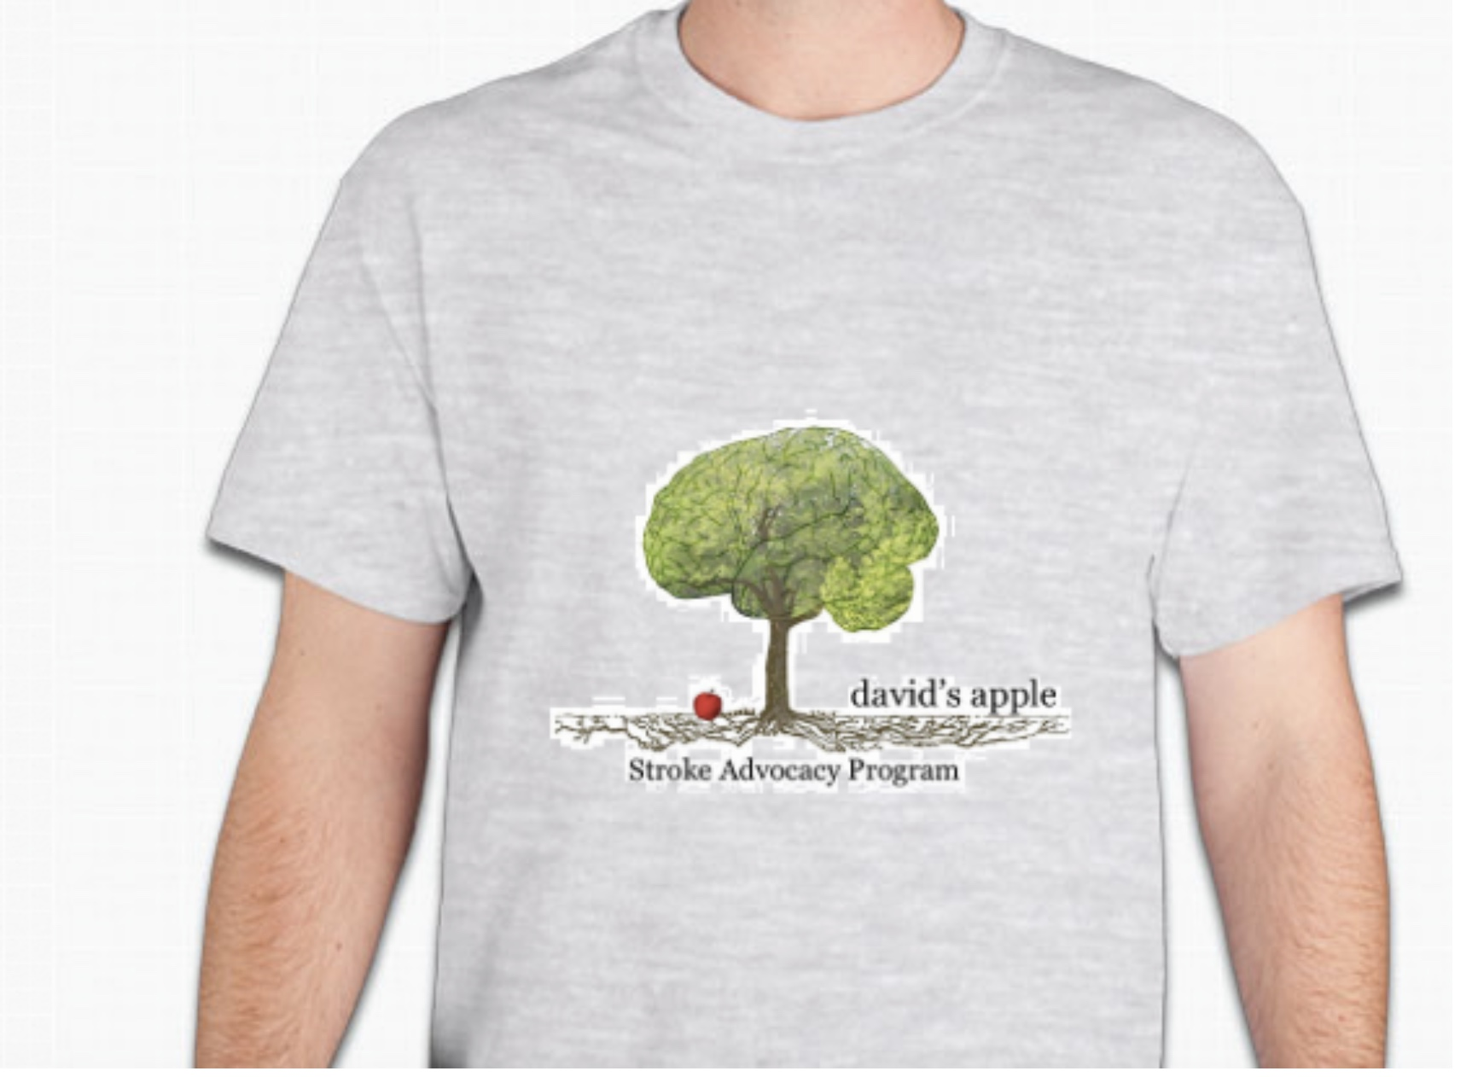
$20 each

Size Selection and Quantity:

S _______ M ________ L ________ XL ________ XXL _________ Total #: ________________

Total Cost: ________________

Date: ____________________________________________________________________________________
Name: ___________________________________________________________________________________
Postal Address: ___________________________________________________________________________
Postal Code: _____________________________________________________________________________
Mobile/Phone: ____________________________________________________________________________
Email: ___________________________________________________________________________________

We will contact you once the t-shirt arrives.

Payment Info:

CASH VENMO CARD

Tax deductible (501c3): #45-2208526

